ACTIVITY: MOVING AROUND THE CITY

Let’s practice making full sentences. In the picture below, you can see a city. You will find some indications to get to different places. Are they true or false? Circle the correct one.

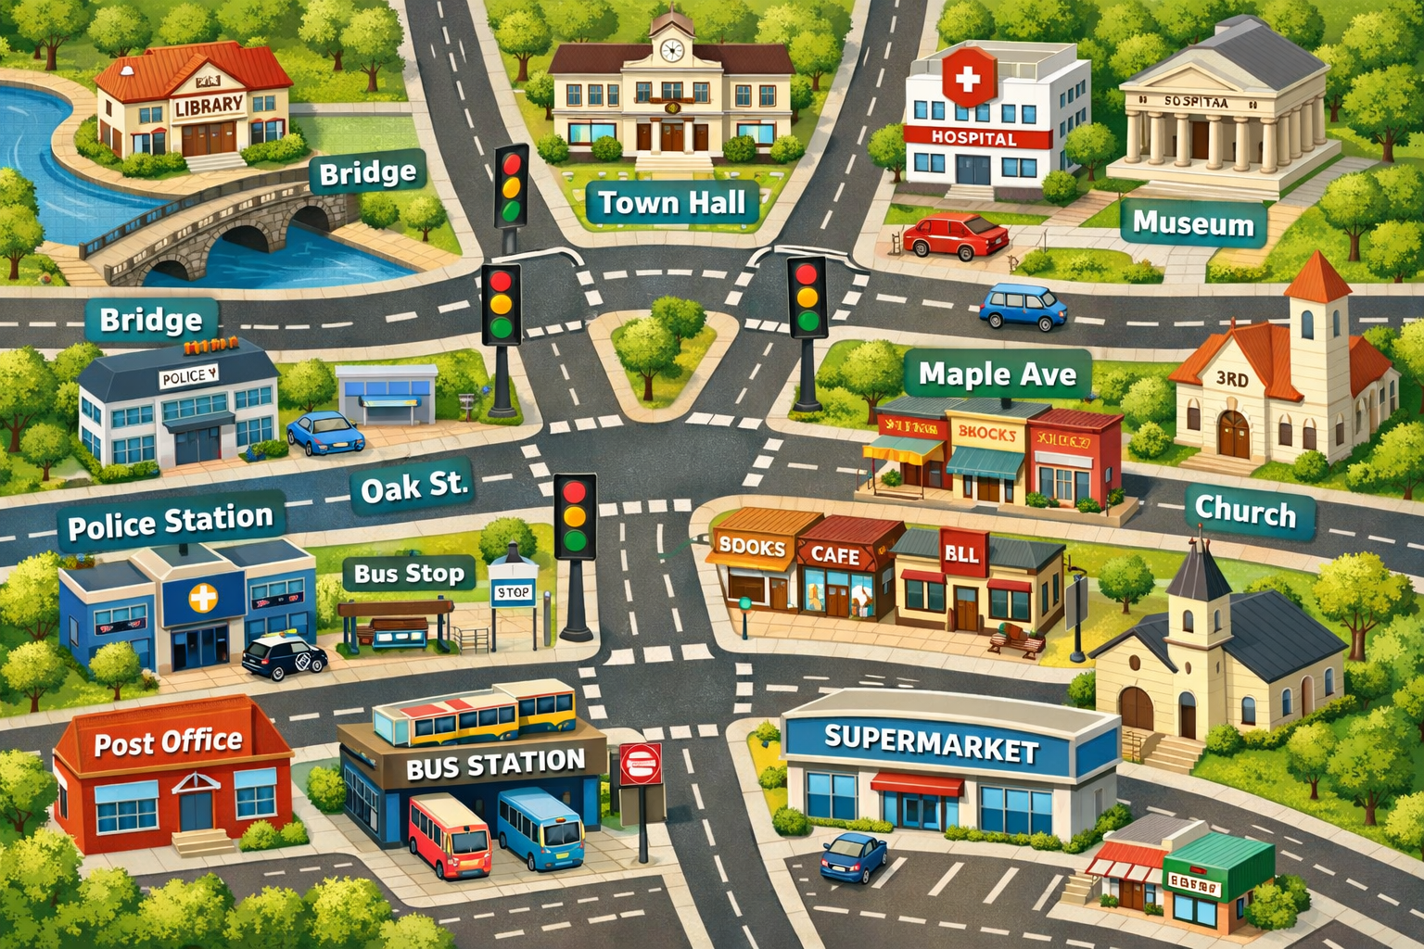

- Starting point: library.
Cross the bridge and turn left, go straight forward and at the traffic lights, turn right. Go past the next traffic lights, and you will find it on your right.

Solution: Church TRUE or FALSE

- Starting point: post office.
Turn left and walk along the street. At the intersection, turn right, and you will find it across the street, between the book shop and the BLL restaurant.

Solution: Café TRUE or FALSE.

- Starting point: Police station.
Turn left and go straight on. At the traffic lights, turn left again. On the corner, turn right and go straight on. You will find it, it is behind the BLL restaurant.

Solution: Hospital TRUE or FALSE.

- Starting point: Church.
Turn right and go straight on. At the traffic lights, turn right and at the intersection, turn right again. Go straight on, and you will find it besides the hospital.

Solution: Museum TRUE or FALSE.

- Starting point: Town hall.
Turn right, and go past the traffic lights. Then, turn left and go along Oak Street. You will find it next to the bus stop.

Solution: Police Station TRUE or FALSE.

